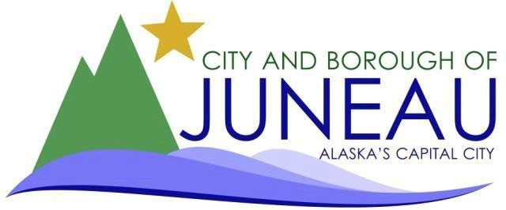

Exit Checklist

This checklist is intended to assist departments and employees with completing the necessary steps when separating from CBJ employment.

The items listed in this checklist should be completed prior to the employee’s last day of work.

Employee name:  Check if Multiple Positions

Department: Employee’s last working day:
Employee Responsibilities Department Responsibilities

- Submit resignation letter
- Contact State PERS 465-4460, particularly if retiring
- Update address in Infor/Lawson – Employee Self Service, OR give forwarding address (for W-2) to your department admin
- Return bus pass to supervisor, if applicable
- Clean out desk or locker
- Submit any outstanding Medical Reimbursement and/or Dependent Care Reimbursement Forms to BAC
- Review and approve your final timecard
- Prior to your last day worked, print out any paystubs you may need, as you will lose access to Employee Self Service after that (Payroll does mail your final paystub to you)
- Update Automatic Reply in Outlook
- Change voicemail greeting, and provide PIN to supervisor
- Limited Governmental Public Notaries must email Notary@alaska.gov upon separation with the date of last performed notarization.
- Regular Public Notaries should email Notary@Alaska.gov to update their contact information or to request deactivation of their commission, if they choose to do so.

**Reminder: Benefits end at midnight on the last day of the current pay period. **
- Send resignation letter to HR and complete “Notify HR of Separation” in SharePoint
- If a supervisor, notify HR & Payroll at least one pay period before their separation date
- Collect Building Keys/Access Card/Fob and return to Facilities Maintenance
- Collect Credit/Purchase Card & Notify AP to cancel credit card
- Audit and approve final timecard
- Collect cell phone/radio/laptop/other
- Collect uniforms/tools, including vehicle keys, and fuel fob
- Email Fleet Admin to remove access to fuel system
- Notify employee of Exit Interview opportunity & provide to HR once completed
- Complete Exit Performance Evaluation
- Email Webmaster to remove WordPress access
- Email HR to remove user access in NeoGov
- Notify Payroll of any outstanding repayment requirements. Example: travel/training, tool allowance, relocation costs, recruitment bonus, longevity bonus, retention bonus, etc. (Payroll may be able to break repayment up over multiple pay periods)
- Update Parking Portal (IPS)
- Email City.Clerk@juneau.gov to deactivate CivicPlus user/agenda manager, if applicable

Employee Signature Date

Supervisor/Dept. Director Signature Date

