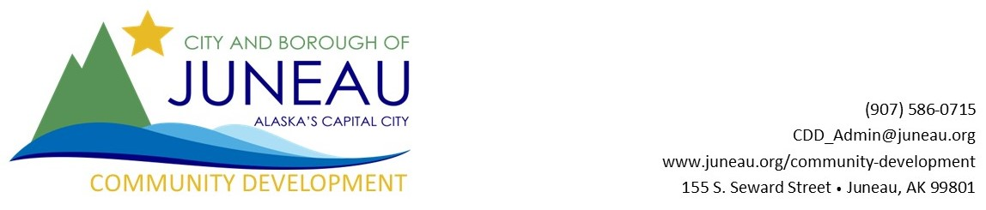

Local Competition for State of Alaska Department of Commerce, Community, and Economic Development (DCEED) Community Development Block Grant Program

Each year the City and Borough of Juneau is eligible to sponsor a local project for the U.S. Department of Housing and Urban Development Community Development Block Grant Program that is facilitated through the State of Alaska Department of Commerce, Community, and Economic Development. CDBG competitive grants are single-purpose project grants; maximum of $850,000 per community.
The goals of the Alaska Community Development Block Grant Program (CDBG) are to provide financial resources to Alaskan communities for public facilities and planning activities which address issues detrimental to the health and safety of local residents and to reduce the costs of essential community services. The program may also fund Special Economic Development activities which result in the creation of jobs for low and moderate income persons.

Local Competition
Interested applicants will need to submit a proposal to the CBJ Development Department by October 23, 2023 at 3:00PM. Email completed applications to Forrest Courtney at forrest.courtney@juneau.gov.

Proposals will be reviewed and scored on the elements in the CDBG Project Proposal Checklist that mirrors information necessary for the final application to the State program.

Community Development Block Grant Project Proposal Checklist
The below checklist should guide the project proposal that will be submitted to the Community Development Department.

□ Brief project description of project & current conditions
□ Paragraph describing citizen participation to-date
□ Outline of project plan implementation and timeline
□ Description of site control, plans, permits etc.
□ State if deed or lease is available
□ State what permits will be needed (if)
□ Are permits in place already… if not how long?
□ Describe architectural or engineering plans completed to-date

□ Paragraph explaining how project will be a benefit to low/moderate income (LMI) persons or identified special populations. Reminder: Each CDBG grant activity proposed must meet the National Objective of benefiting populations or targeting areas which consist of at least 51% low and moderate-income persons, as defined by 2021 HUD LMI data, based on 2011-2015 American Community Survey (ACS). Juneau, as a whole, does not meet the 51% threshold so each project must meet this criteria on its own.

□ If not a special population how are LMI identified and documented (survey’s may be needed) State CDBG administrative staff have to approve LMI documentation

□ Budget outline
□ Amount of CDBG request
□ Total project cost
□ Matching funds and source

□ Administrative capabilities – briefly describe past grant management

