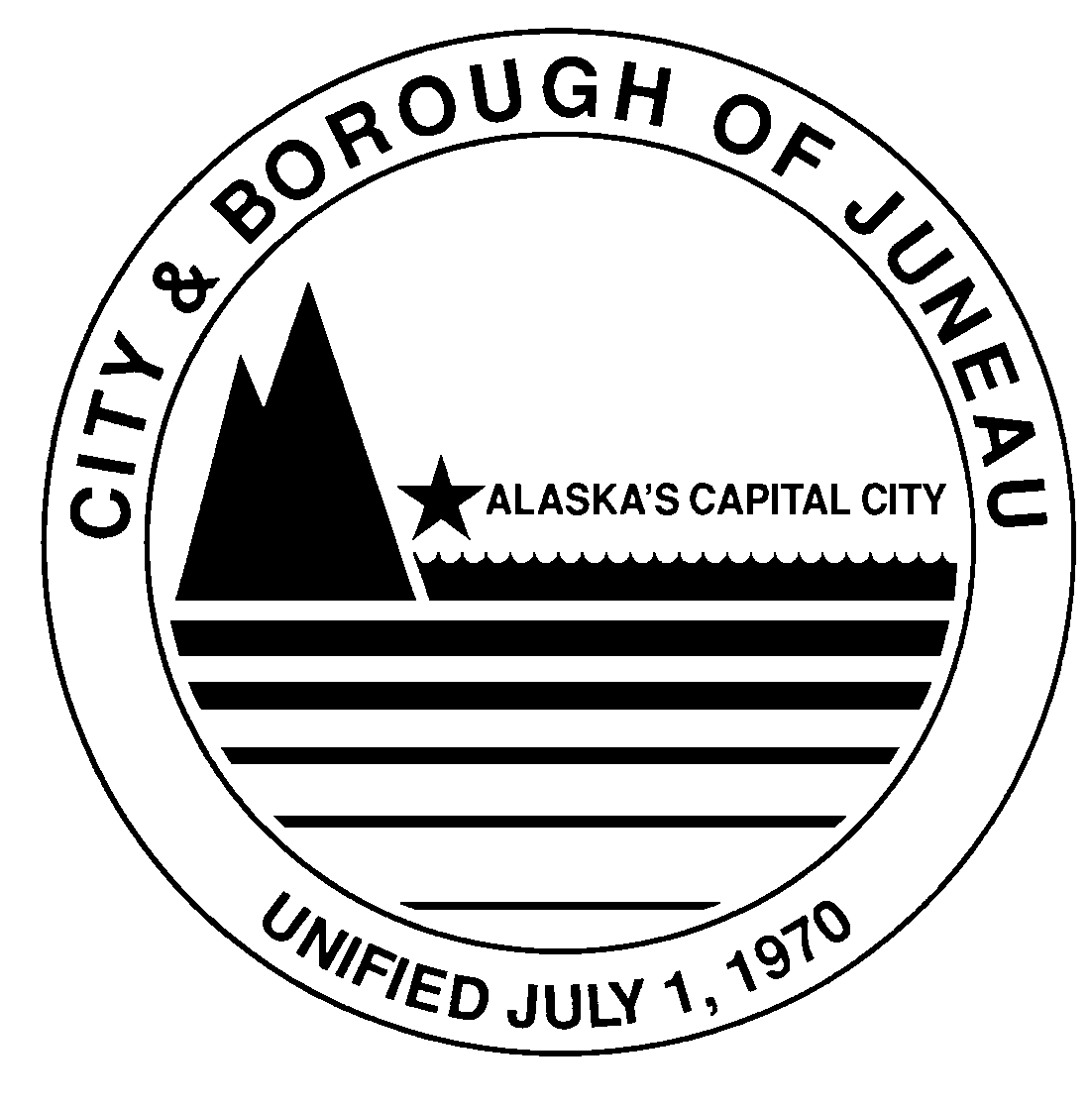
CITY AND BOROUGH OF JUNEAU, ALASKA
NOTICE OF PROPOSED CHANGE TO REGULATIONS
Commercial Use of Aquatics Facilities Regulation 11 CBJAC 02

Purpose:
Notice is given that the CBJ Aquatics Board, under the authority of CBJ 01.60.200, CBJ 67.10.020(a)(3), and CBJ 67.01.090(i), proposes to amend the regulations found in Title 11 of the Administrative Code of Regulations, by adding Chapter 02, Commercial Use of Aquatics Facilities.

NEW Proposed Regulation:

See full text of the proposed regulations at: https://juneau.org/law-department/cbj-regulations

Summary:
The proposed regulations would authorize the Aquatics Manager to issue permits for commercial use of aquatics facilities per CBJ 67.01.090(i); require applicants to provide proof of liability insurance per CBJ 67.01.080; allow the Aquatics Manager to require reasonable conditions, such as to time, area, equipment, training, certification, insurance, and other factors; authorize the Aquatics Board to set an Application Fee and a Permit Fee for commercial use; and establish general operating requirements for commercial use of aquatics facilities.

The adoption of these amendments should not require any increased appropriations by the municipality. The adoption of these amendments would allow the Aquatics Board to require persons subject to the regulations to pay a one-time application fee and a commercial use permit fee. The Aquatics Board has set the Application Fee at $100 and the Permit Fee at $0 per user day.

Public Comments Requested by September 1st, 2021:
Written public comments will be taken until 4:30 pm on Wednesday, September 1st, 2021, and should be emailed to parks.rec@juneau.org or mailed or delivered to: Kollin Monahan, Aquatics Manager, 155 S. Seward St., Juneau, AK 99801.

Published __08/12/21__

