CVB discusses tourism best management practices

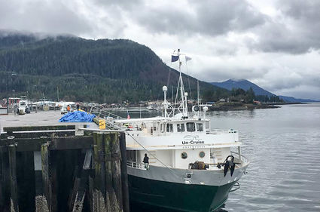
WRANGELL - Wrangell's Convention and Visitor Bureau met last Monday, Dec. 23, to continue their ongoing work on putting together a "tourism best management practices" document for the city. This conversation began back in November. A growing tourism industry in Wrangell has highlighted the need for some form of guidelines, as well as concerns about how future tourism might impact the community's day-to-day life. Tourism best management practices, or TBMPs, are a way to help ease friction between tourism related companies and the wider public.
"Juneau and other communities are doing this, and it's been a way to have a real positive effect for both tourists, but it's more for local residents," said Brenda Schwartz-Yeager. "Juneau's been doing it for 20-some years really successfully."
In previous meetings on the topic, Economic Development Director Carol Rushmore said that they were basing Wrangell's own TBMP document off of Juneau's. Juneau's TBMP document for 2019, which can be found online, lays out guidelines for all tour operators and other tourism-related businesses to follow. These range from agreements to keep the streets outside of businesses clean, to being courteous with the use of parking spaces, to limiting engine idling time. The guidelines also allow for other people, be they fellow business people or city residents, to voice complaints if there is a problem. Juneau's document is 36 pages long. The bureau agreed that a TBMP document for Wrangell did not need to be so long or extensive. Much of the discussion revolved around what items could potentially be added or expanded upon.
"I don't really think we've had that many complaints to be quite honest with you," Rushmore said. "So I don't think we want to go overboard and make something an issue if it's not an issue."
One of the bigger topics discussed was parking around Mt. Dewey, Petroglyph Beach, and other popular tourist spots in town. Another issue the bureau brought up was idling jet boats. Tour boats come up to city dock to pick up and drop off passengers, and will keep the engine running while doing so. However, keeping the engine idling can create a current out from the dock that can make it challenging for other boats to pull up to the floats easily. Yeager also added that she would like to see something in the document regarding boating etiquette when traveling up and down the Stikine River.
Work on these tourism best management practices is still ongoing.

