Public Comment Review - DRAFT
July 2027

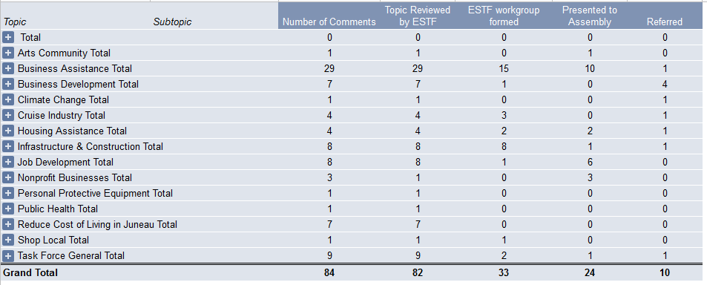
Comments after July 9th
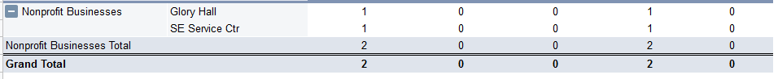

Outstanding Themes from Public Comments and April 30th Business Recommendations memo
Construction - CBJ Permitting changes – remove barriers, reduce fees
Tourism - CBJ Fees
- Refund CBJ Fees paid for 2020 season, defer 2021 fees until later in season
- Expedite sales tax refunds from returns/refund requests
- reduce fees for dock front sales booths, freeze permit costs, reduce Dock Passenger fees
Renewable energy – define ways to further programs to reduce energy costs – near term cost savings, long term benefit. Such as Heat Smart
Downtown property tax/rent relief – various suggested forms:
- In fall, adjust property taxes on empty buildings
- Incent downtown landlords to reduce rents with reduced property tax

Tourism - Focus on 2021 season – define ways to aid businesses in preparation for it
- reduce expenses so businesses have ability to get up and running (rent, taxes, fees)
- support small cruise industry, as large cruise industry may take longer to rebound

Promote downtown business:
- Designated curbside pickup spots
- Sales tax free days
- Enforce tax collection from online retailers
Commercial Fisherman support
- Moorage fees, safe dock sales, marketing support,
- Community cold storage facility
Specific projects
- Remove city barriers to archipelago project
- Juneau Access

Expand JOS
Job training initiatives - in general, but also, to ensure that the jobs created by other initiatives can be filled by local candidates.

Other thoughts:
Eviction moratoriums lifting – programs to incent landlords to defer eviction of commercial tenants
- Lease negotiation support
- Reach out to attorneys who might offer pro bono support to assist
Heading into winter – aggregating resources for utility support for residents/businesses

